Cancer and Palliative Care Workshop Speaker Biographies
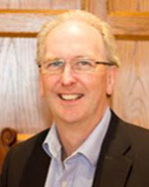  Professor Sean Duffy  Strategic Lead Cancer Clinician  Program Clinical Director for WYICS | Professor Sean Duffy is the lead for the West Yorkshire and Harrogate Cancer Alliance. He is also the strategic clinical lead for the Leeds Cancer Centre. Prior to these roles he was the National Clinical Director for Cancer for NHS England during which the new strategy for cancer (Achieving World Class Cancer Outcomes) was developed and published. Prior to this he was the Medical Director and Director of the Yorkshire Cancer Network until its dissolution in 2013 when he took up his national role.  Sean’s clinical and academic activity encompassed medical education, health services research and gynaecological cancer. He has supervised successful post graduate research programmes and has wide ranging national and international publications. He maintains a clinical practice in gynaecology in St James’s Hospital Leeds.
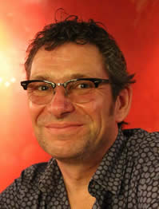  Professor Richard Neal  Professor of Primary Care Oncology, University of Leeds | Professor Richard Neal returned to Leeds in August 2016 from Bangor University where he was Professor of Primary Care Medicine and Director of the North Wales Centre for Primary Care Research.  Prior to this he was a Research Training Fellow, Lecturer and Senior Lecturer at the Centre for Research in Primary Care at the University of Leeds.  His main research interest is the interface of cancer with primary care, especially relating to early diagnosis and survivorship. This is driven by a desire to improve outcomes for patients with cancer, by understanding and changing the ways in which their diagnosis and survivorship experience is influenced by primary care.
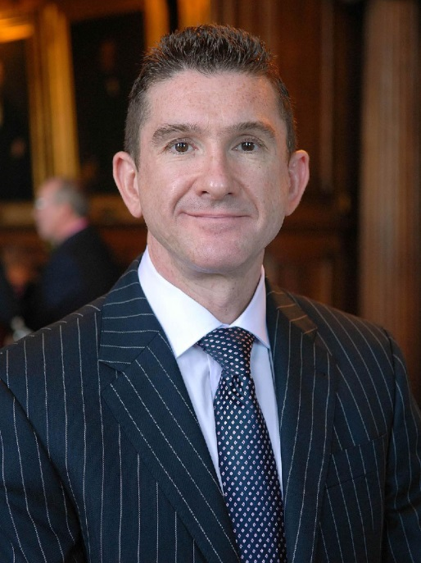  Professor Mike Bennett  St Gemma’s Professor of Palliative Medicine, University of Leeds | Professor Mike Bennett is the St Gemma's Professor of Palliative Medicine and works clinically as a Consultant at St Gemma's Hospice in Leeds. He is based at the Academic Unit of Palliative Care since his appointment in 2011.  His main research interests are in pain management in advanced disease, and evaluating decision making and interventions at the end of life.  He has been Cochrane Field Editor for palliative and supportive care, has chaired the National Cancer Research Institute palliative care studies group from 2008 and has chaired scientific and organisational committees for several research congresses of the European Association for Palliative Care (EAPC). He chairs the Cancer Pain Committee for the International Association for the Study of Pain (IASP).
Dr Matthew Mulvey  Research Fellow, Academic Unit of Palliative Care, University of Leeds | Dr Matthew Mulvey is a Research Fellow and his post is funded by the National Institute for Health Research. His research focus is to better understand the prevalence and mechanisms of cancer neuropathic pain, through detailed assessments using quantitative sensory testing (QST) techniques and longitudinal study of patients with cancer neuropathic pain. He is also interested in developing and testing self-management tools to facilitate patient decision making with regard to management of pain relief in patients approaching the end of life.  Prior to his present role, Matthew was a Research Associate at the Arthritis Research UK Epidemiology Unit, Institute of Inflammation and Repair, University of Manchester.
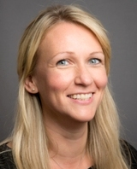  Dr Lucy Ziegler  Senior Research Fellow, Academic Unit of Palliative Care, University of Leeds  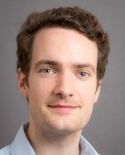  Dr Matthew Allsop  Research Fellow in Applied Health, Academic Unit of Palliative Care, University of Leeds | Dr Lucy Ziegler’s research forms part of the IMPACCT programme and aims to improve the management of pain in patients with advanced cancer through better understanding the profile of prescribing for cancer pain in the last year of life and exploring possible mechanisms to improve access to medicines such as non-medical prescribing. This work will inform interventions to enable patients to remain at home with well-controlled pain at the end of life.  Lucy has undertaken research aimed at improving the quality of life of cancer patients since 2001, at the University of Bradford (2001–2008) and more recently within the Psychosocial Oncology and Clinical Practice Research Group, University of Leeds (2008–2012).  Dr Matthew Allsop’s research focuses on engaging users in the design and development of healthcare technology with a focus on palliative care services in Europe and sub-Saharan Africa. He has conducted user involvement research across a range of disciplines, including rehabilitation medicine, neurosurgery and ophthalmology. Matthew is also a Public Engagement Fellow for the Faculty of Medicine and Health, supporting public engagement activities across the School of Medicine.  Matthew is based in the Academic Unit of Palliative Care funded through IMPACCT (Improving the Management of Pain from Advanced Cancer in the Community), an NIHR programme grant. His role involves developing an electronic pain reporting system for patients with cancer and evaluating its use in a feasibility trial. Matthew is also leading the dissemination strategy for the overall programme grant and writing the final funders report.
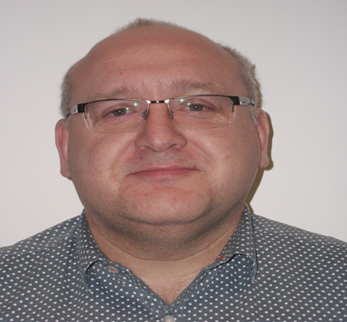  Paul Carder  Head of Research,  West Yorkshire Research & Development | Paul Carder has been working in research-related roles in both academia and the NHS for over 10 years, contributing to large national programmes of research and evaluation within both. Recent time has been spent overseeing the research and evaluation activity within primary care across the whole of West Yorkshire, starting with the clustered PCTs and now acting on behalf of all the CCGs and general practices therein.  Prior to this Paul worked as a University Researcher/Lecturer in the Department of Economics at the University of Essex.  Recently Paul has been involved in a lot of work for the CLARHC, a large research project designed by the NIHR to ensure that academic research is applied within the health care environment across the whole of the health economy of York, Leeds and Bradford.
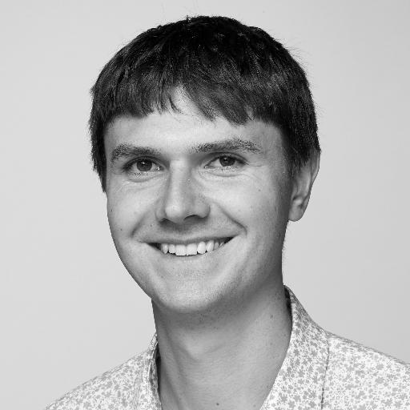  Dr Sam Smith  Cancer Research UK Postdoctoral Fellow, University of Leeds | Sam Smith is a Cancer Research UK Postdoctoral Fellow and University Academic Fellow. His current work is investigating decision-making in the context of breast cancer prevention. He is particularly interested in the uptake of breast cancer chemoprevention using hormonal agents.  Sam's academic background is in behavioural science and health psychology. His PhD thesis investigated the potential of 'gist-based' information to promote colorectal cancer screening uptake among low literacy groups. This work was funded by a Medical Research Council studentship, and an NIHR programme grant (PI: Raine).  After his doctoral studies, Sam was awarded a postdoctoral fellowship in the Division of General Internal Medicine, Northwestern University, Chicago, Illinois. Under the supervision of Professor Michael Wolf, the focus of his research was using existing data to establish the effect of health literacy and patient activation on patient outcomes.

